Supplementary Table 1. Real Time mixture

No. | Reagent | Volume
1 | cDNA | 1 µl
2 | Sybr Green qPCR Mix, 2X | 10.4 µl
3 | Primer forward | 0.5 µl
4 | Primer reverse | 0.5 µl
5 | H2O PCR grade | 7.6 µl
6 | Total volume | 20 µl

Supplementary Table 2. Real Time program

No. | Real Time step | Temperature (°C) | Duration | Cycle
1 | Initial activation | 95 | 3 min | 1
2 | Cycles of denaturation | 95 | 20 sec | 1
3 | Annealing and extension | 60, 58 | 20 sec | 1
4 | Elongation | 72 | 1 sec | 45

Supplementary Table 3. Primer sequences of studied genes and the internal control gene

Gene name | Primer name | Primer sequence | Product size
GAPDH | GAPDH (F) | CCACTCCTCCACCTTTGACGCT | 139
GAPDH | GAPDH (R) | TTACTCCTTGGAGGCCATGTGGG | 139
Caspase 3 | Caspase 3 (F) | TCCTTTTCCTTTGACGCTACTT | 111
Caspase 3 | Caspase 3 (R) | AACCACCAACCAACCATTTC | 111
P21 | P21 (F) | TTGTACCCTTGTGCCTCGCTCA | 128
P21 | P21 (R) | AGATCAGCCGGCGTTTGGAGT | 128
P53 | P53 (F) | CCACCATCCACTACAACTAC | 135
P53 | P53 (R) | AAACACGCACCTCAAAGC | 135

B
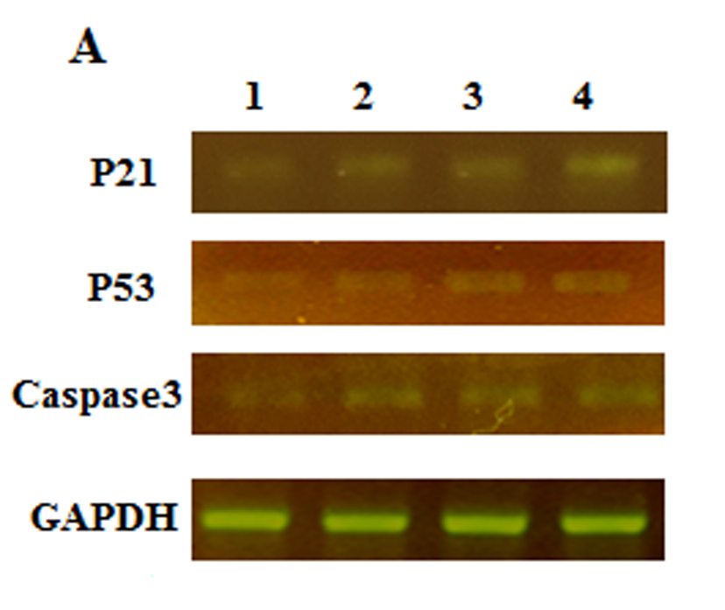

Supplementary Figure 1. Gene expression control groups and co-culture. A: Total RNA isolation and cDNA was synthesized, samples were compared with based on the expression of GAPDH gene. PCR products were electrophoresis in 2 % agarose gel to analyze the expression of genes of P21, P53, Caspase3 and GAPDH, Lane 1: cell line HT29, Lane 2: AM-MSC, Lanes 3 and 4: co-culture (HT29 with AM-MSC), P21, P53 and Caspase-3 were expressed in co-culture treatment groups compared with cell line HT29. B: to evaluate gene expression of p21, P53 and caspase3 Real Time-PCR assay were used, P21, P53 and caspase3 were significantly highly expressed co-culture groups compared with control cell line HT29.

